**CHATBOT TO SHOP FOR ESSENTIALS DURING PANDEMIC USING WATSON ASSISTANT**

-Elizabeth Mathew

1. INTRODUCTION

1.1 Overview

It has gotten increasingly risky for people to shop for essential items in person, due to all the social distancing and the pandemic as a whole.

1.2 Purpose

The purpose of this project is to help people do this. It gives people an online option to shop. Using Watson Assistant, a chatbot was made.

2. LITERATURE SURVEY

2.1 Existing Problem

It is also difficult to formulate and implement guidelines that apply to all types of stores because of variations in store layout, customer flow, and the willingness of customers to comply with social-distancing advice. To make matters even more difficult, it takes very little for COVID-19 to transmit.

2.2 Proposed Solution

The proposed solution is a chatbot to help people accomplish, through the internet, what they used to do before. It allows them to get their essentials without leaving the comfort of their home and risking themselves by going out. The chatbot should have the following capabilities-

1. Give the list of items in the Store.
2. Should show the  prices of vegetables
3. Display if there are any offers or discounts
4. The bot should be able to take details like name, contact number, address, and the items to place the order.

3. THEORETICAL ANALYSIS

3.1 Block Diagram

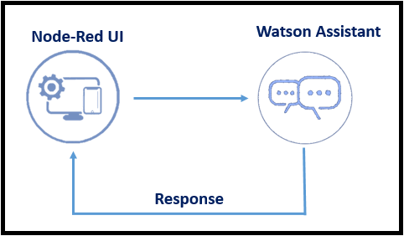

3.2 Hardware/Software Designing

a)IBM Watson Assistant

b)Node-Red

4. EXPERIMENTAL INVESTIGATIONS

Made greetings intent

Made greetings entity

Made questions intent

Made questions entity

Made questions dialog-

🡪List/items

🡪Prices

🡪Offers

🡪discounts

Created order intent

Order entity

Made name entity

Made entity address

Made entity email

Slots(for ordering)-Added name, phone no. (sys entity), address, email, items, quantity

Cleared context variables

Node Red -

Opened service 🡪 opened flow editor

Integrated node red with Watson assistant

5. FLOWCHART

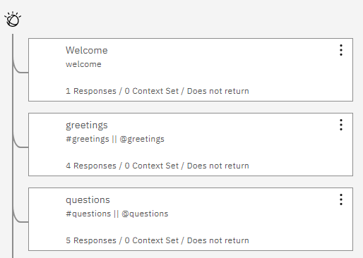

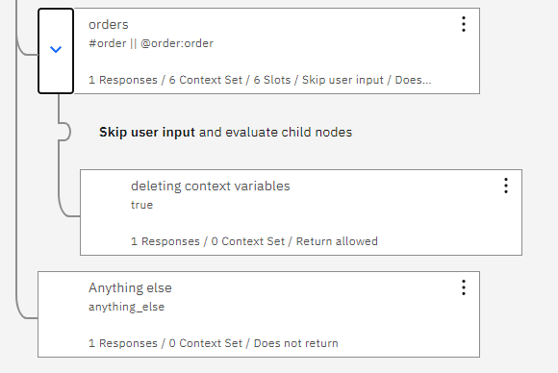

6. RESULT

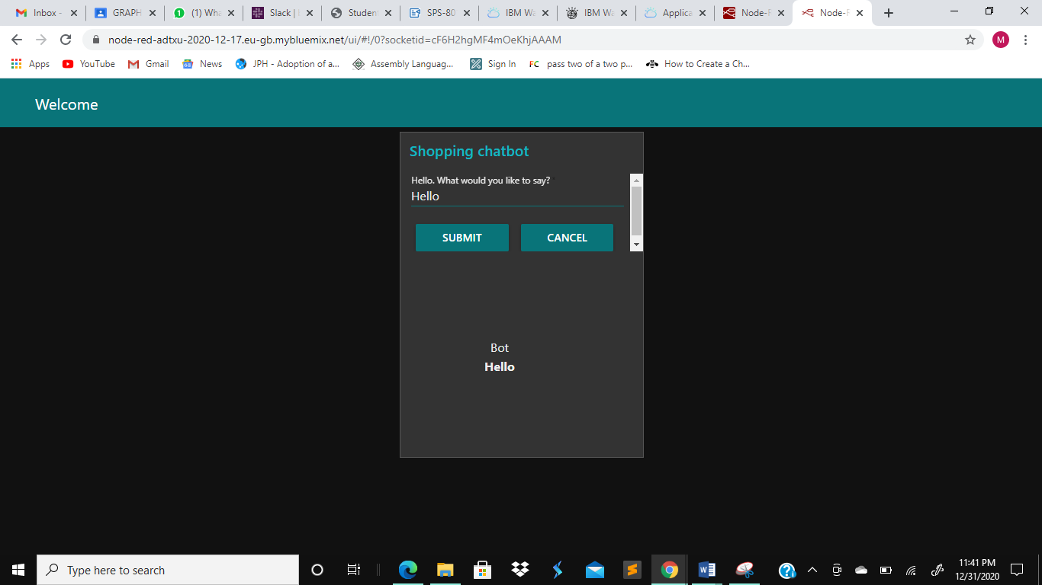

greeting

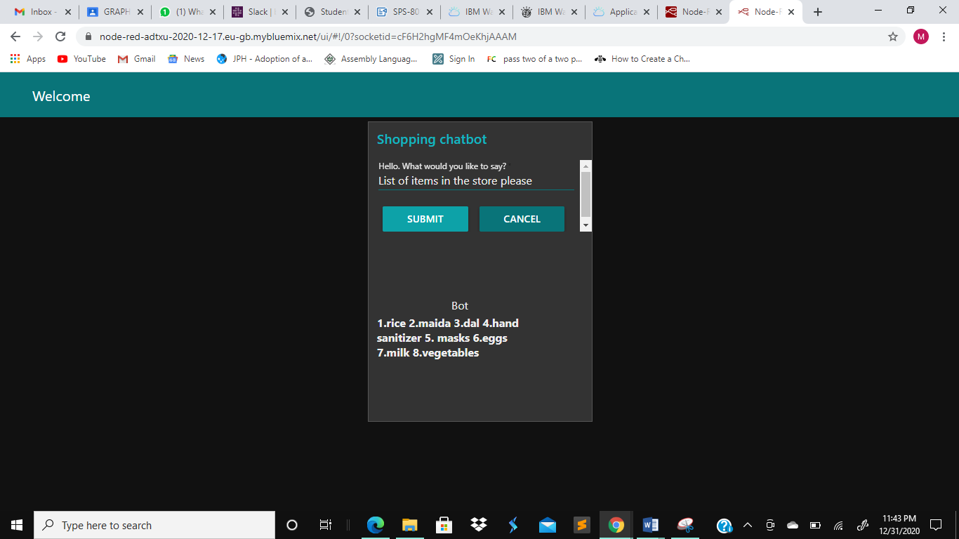

List of items in the shop

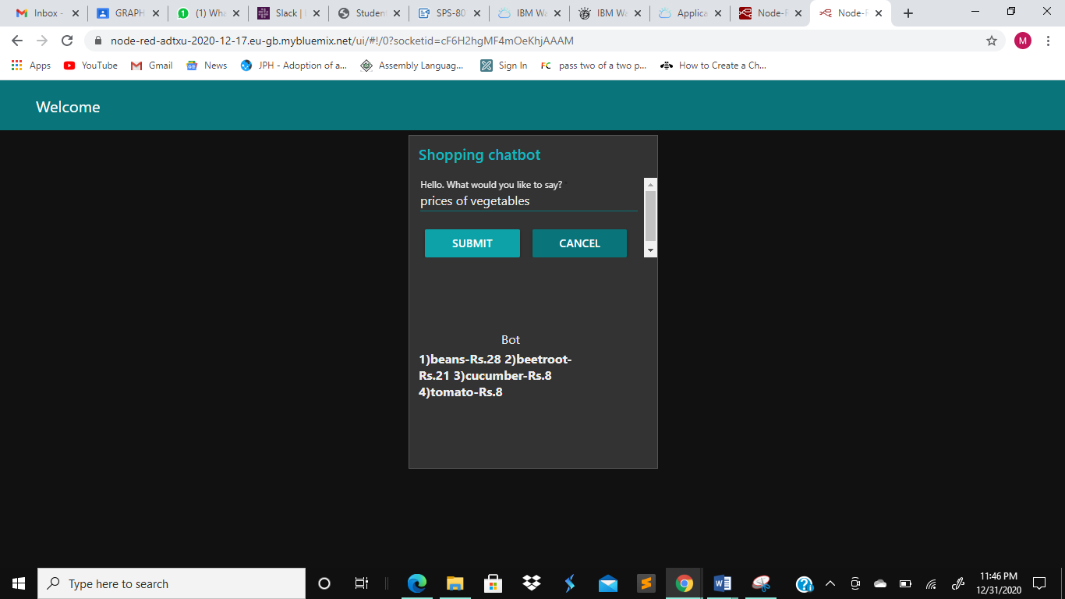

Vegetable prices

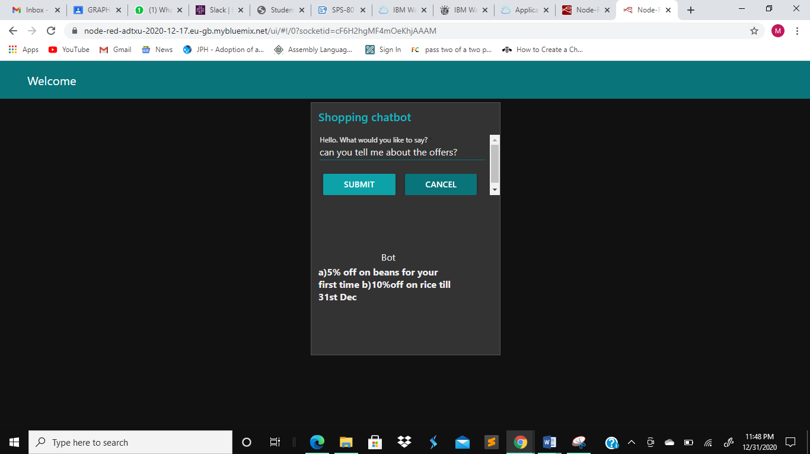

Offers

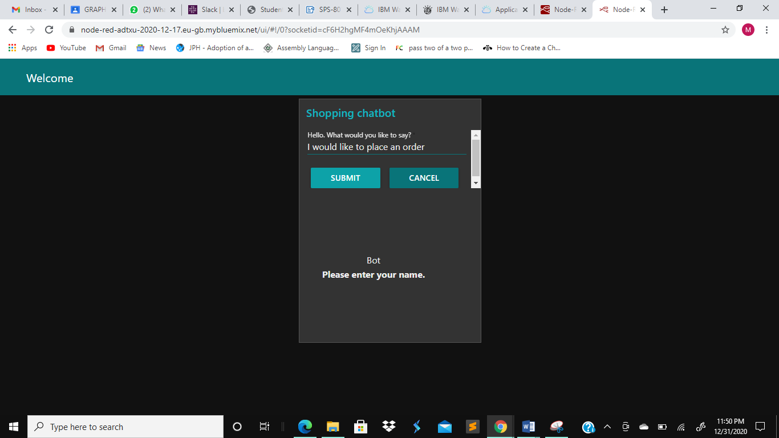

Placing an order

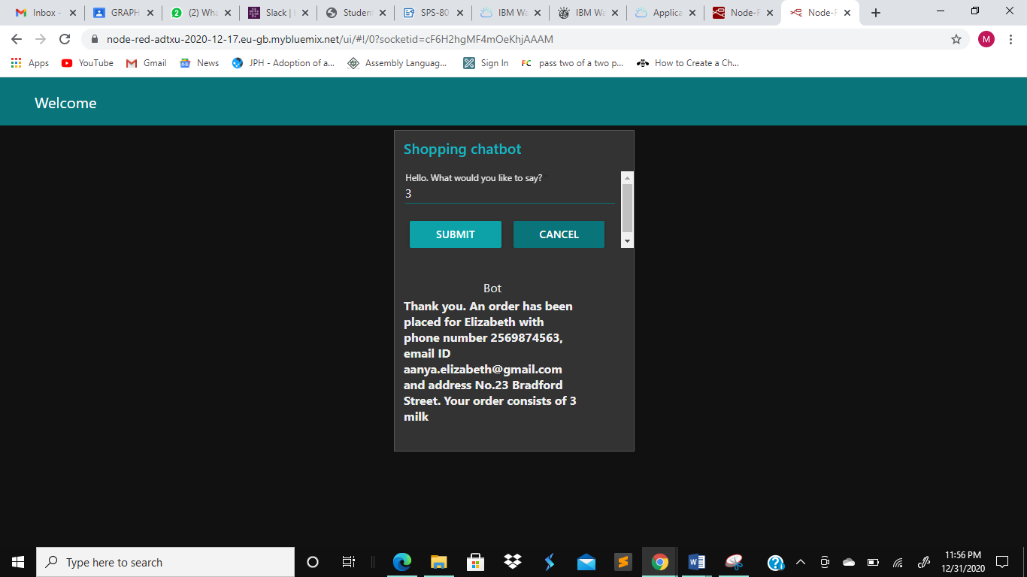

Result after placing the order

7. ADVANTAGES AND DISADVANTAGES

Adavantages-

1. 24x7 support- Most customers expect businesses to be available 24 hours a day, 7 days a week. While having a customer service team around-the-clock is an (expensive) option, with chatbots you can eliminate that cost and still ensure your customers are catered to immediately by chatbots – irrespective of what time of the day it is. Offering 24-hour support is a great way to ensure customer satisfaction.
2. Chatbots can also be used to collect data about your visitors and use it to make better product suggestions and recommendations. Understanding customer inquiries, their needs and preferences can allow you to personalize product pages and build customer loyalty and affinity.
3. Having chatbots do most (or probably all) of your customer service activities can help you save a substantial amount of money on your customer service team.

Disadavantages-

1. Lacks emotions- Unlike humans, a chatbot has no emotions.
2. Difficult to create- It is very challenging to create a chatbot from scratch. It requires that you invest significant time and effort into creating it.
3. Require maintenance- Chatbots require ongoing review, maintenance, and optimization in terms of their knowledge base and the way they are supposed to communicate with your customers.

8. APPLICATIONS

This chatbot will be useful for people to buy essential items online at a time when it is detrimental to their health to go outside. They can find out all the items the store sells, the offers or discounts it provides and it also gives them the provision to place orders.

9. CONCLUSION

As established, this can help prevent a lot of people from falling prey to the vicious pandemic that is currently raging around the world. By ordering from home, they remain safer by staying indoors, especially the elderly. This would also be a way for them to find out about offers and capitalize on it.

10. FUTURE SCOPE

Chatbots are found more in bigger, wealthier e-commerce sites. If regular shops could start using this technology then it would be easier for the people who live near it to obtain their essential groceries.

11. BIBLIOGRAPHY

<https://smartinternz.com/Student/badge_workspace/8013>

Robert Shumsky and Laurens Debo, What Safe Shopping Looks Like During A Pandemic[July 24,2020], accessed on Dec 31 2020, Available at-<https://hbr.org/2020/07/what-safe-shopping-looks-like-during-the-pandemic>

Manan Thakkar, 5 Benefits Of E-commerce Chatbots & How To Use Them Effectively[July 28,2018], accessed on Dec 31 2020, Available at-

<https://synoptek.com/insights/it-blogs/5-reasons-using-chatbots-in-ecommerce-a-great-idea/>

Aivo, Advantages and Disadvantages of Chatbots You Need To Know,[Dec 5,2019], accessed on Dec 31 2020, Available at-

<https://www.aivo.co/blog/advantages-and-disadvantages-of-chatbots#:~:text=One%20of%20the%20greatest%20disadvantages,in%20a%20bot%2Dfriendly%20way>.

APPENDIX

1. Source Code